Landing, Login, and Enrollment Pages Development paper

CST499

Professor Rangitsch

Brian Ivers

2/17/25

The front-end and back-end aspects of development must be understood in order to create web apps. The creation of a basic PHP web application with XAMPP is examined in this paper. A landing page, login page, registration page, MySQL database for user data storage, and a custom database connection class are some of the main elements of the application. We can show how to create a user registration and login system that is both efficient and safe by putting these features into practice.

**Running a PHP File in XAMPP**

Use these procedures to launch a PHP file in XAMPP:

1. Launch the Apache and MySQL services by opening XAMPP.
2. The htdocs directory, usually located at C:\xampp\htdocs\my_project, is where you should save the PHP file.
3. To run the PHP file, launch a web browser and type <http://localhost/my_project/index.php>.

These procedures guarantee that the PHP file is run correctly in the XAMPP-provided local server environment.

**Landing Page, Login Page, and Registration Page**

The project consists of three pages:

* Landing Page: Offers a logout option along with a welcome message.
* Login Page: Users can authenticate using their email address and password on the login page.
* Registration Page: New users can create an account on the registration page.

These pages are essential to user engagement since they provide safe login for current users and registration for new users.

**Creating the MySQL Database and Tables**

The following SQL queries were run in phpMyAdmin in order to store user data:

These commands generate a new database and table to hold user data, including password, email address, and username. To provide security, the password is hashed.

**MySQL Database Functions and Database Connection Custom Class**

To manage connections, the project makes use of a ‘Database’ class:

This class can be used to communicate with the MySQL server throughout the project and guarantees a secure connection to the database.

**Registration Page Layout and PHP Source Code**

A straightforward form for user feedback can be found on the registration page:

The PHP script manages password hashing, input validation, and form submissions:

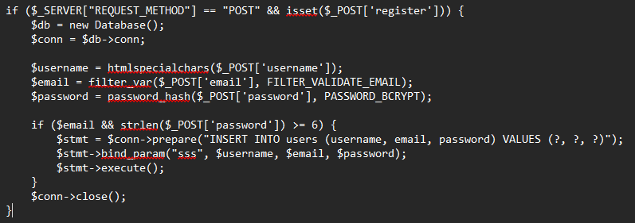

**Steps to Create the Registration Page and Save User Data**

1. Make an HTML form that users may fill out.
2. Verify inputs to make sure they are formatted correctly.
3. Use ‘password_hash()’ to hash passwords.
4. Using a prepared statement, enter data into the ‘users’ table.
5. After a person has successfully registered, redirect them.

To sum up, this PHP web application shows how to use XAMPP and MySQL to build a straightforward and safe user registration and login system. The program is made secure and useful by integrating input validation, password hashing, and a new database connection class. Through the implementation of these development stages, developers may create a solid basis for web applications that effectively manage data storage and user authentication. The project demonstrates fundamental PHP development abilities and offers a clear illustration of how to design online apps with security in mind.

***References:***

* Lentz, J. (2017). *Beginning PHP and MySQL: From Novice to Professional* (5th ed.). Apress.
* Welling, L., & Thomson, L. (2016). *PHP and MySQL Web Development* (5th ed.). Addison-Wesley.
* Tsui, F., Karam, O., & Bernal, B. (2018). [*Essentials of software engineering*](https://uagc.instructure.com/courses/142034/modules/items/7241502)(4th ed.). Jones & Bartlett Learning.
* Hosting, S. W. (2021, August 17). PhpMyAdmin Database Management Tutorial. SiteGround. <https://www.siteground.com/tutorials/phpmyadmin/database-management/>
* ProgrammingKnowledge2. (2023, April 1). How to install PhpMyAdmin on Windows [Video]. YouTube. <https://www.youtube.com/watch?v=dnBa2pTKYY0>